Oop questions

C1

1. **Which of the following is the correct statements from church's hypothesis:**
2. Number of instructions must be unlimited.
3. There is no guarantee that an output will be produced because there are an infinite number of steps.
4. It should not be imaginary, i.e. can be made in real life.
5. It should be supported by in-depth research and complex understanding.
6. **„Our language shapes our reality. In other words, the language that we use shapes the way we think and how we see the world.**

**Some concepts might be more effectively communicated in one language than another.”**

**To whom does the stated hypothesis belong?**

1. Edward Sapir and his student Benjamin Whorf
2. Stephen Kleene
3. Thomas Watson
4. Alan Turing

(Ex. Object-oriented programming uses objects, but not all of the associated techniques and structures are supported directly in languages that claim to support OOP.)

1. **Which of the following options is NOT a characteristic of object-oriented programming(OOP)**
2. A new approach to developing applications that begins with a natural representation
3. The agents responsible for an action are called Objects
4. The components of the programs are made to function independently from one another and each have their own characteristics and functionalities.
5. There are no interactions / associations of objects within the program

C2

1. (.5.6.7)**Choose the definition of abstraction/encapsulation/ inheritance/ polymorphism**
2. process of showing only essential/necessary features of an entity/object to the outside world and hide the other irrelevant information.
3. bundling data and methods that work on that data within one unit (i.e. class)
4. A class (subclass) acquires the properties and behavior of another class (super-class)
5. present the same interface for several different underlying data types and different objects to respond in a unique way to the same message.

8. **Which are the characteristics of an object?**

1. identity
2. state
3. behavior
4. location
5. **What is the wrong definition of a class?**
6. A class is a blueprint for creating **objects**
7. A **class** is an extensible program-code-template for providing initial values for [member variables](https://en.wikipedia.org/wiki/Member_variable) and member functions or [methods](https://en.wikipedia.org/wiki/Method_(computer_programming))
8. A class is a set of instructions to build a specific type of object
9. A class is an abstract [data type](https://techterms.com/definition/datatype) created by a developer
10. **We have a class „animals”. Which of the following can be an object of this class:**
11. Number of legs
12. Bark
13. Dog
14. Creature

OPTIONAL

C3

1. (12.13.14.15.)**Recognize the model in the representation and choose the name of it:**

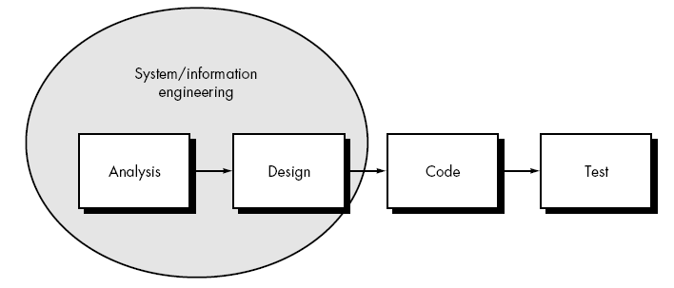

1. Linear sequential
2. Agile
3. Waterfall
4. V shaped
5. spiral

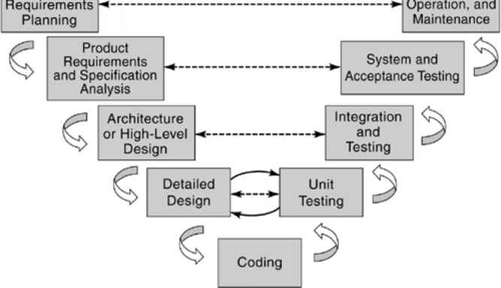

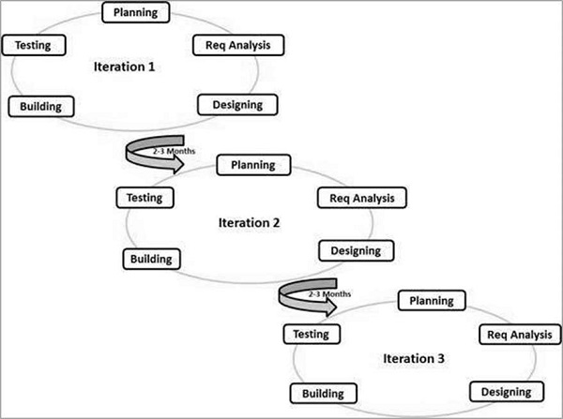

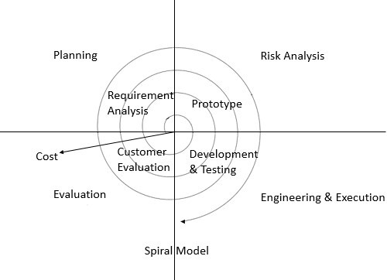

1. **Put the phases of the software development life-cycle in the order:**
2. System analysis

!Aceasta este ordinea corecta

In cadrul jocului vor aparea in ordine aleatorie

1. System design
2. Programming
3. Testing
4. Implementation
5. Maintenance